Brain Tumor Detection and Classification

Hensika Bishnoi
PG student, SCSET
Bennett University (Times of India Group)
Greater Noida, U. P.
hensika.bishnoi@gmail.com
line 1: 4th Given Name Surname
line 2: dept. name of organization
line 3: name of organization
(of Affiliation)
line 4: City, Country
line 5: email address or ORCID
Eeva Mehra
PG student, SCSET
Bennett University (Times of India Group)
Greater Noida, U. P.
eevamehra.work@gmail.com
Aakriti Jain
PG student, SCSET
Bennett University (Times of India Group)
Greater Noida, U. P.
jain11aakriti@gmail.com

Abstract—Brain tumors are a major challenge in medical diagnostics due to their rapid growth and complex imaging. By leveraging a large and diverse dataset which comprises of images of various types of brain tumors, including glioma, meningioma, pituitary tumors, and non-tumor cases, this study aims to evaluate the performance of four different models: Vision Transformer (ViT), ResNet50, VGG16, and Long Short-Term Memory (LSTM) networks. After an extensive and detailed analysis of each model’s performance, our results contribute to the field of medicine and diagnostics, highlighting the crucial role of machine learning and deep learning techniques in the advancement of medical imaging and improvement of patient outcomes for brain tumor classification.
Keywords—brain tumor, MRI, vision transformer, image classification.

Introduction
Statistically it was estimated by the World Health Organization (WHO) that brain tumors cause 1.3% of cancer-related deaths globally and 2% of all cancer cases [1]. These growths can seriously impair a patient's health and quality of life and could be either benign (non-cancerous) or malignant (cancerous). For prompt action and better patient outcomes, brain tumors must be identified early and accurately classified. Developments in medical imaging methods, including computed tomography (CT) and magnetic resonance imaging (MRI), have transformed the diagnosis and treatment of brain malignancies in the last several decades. Researchers and medical professionals have resorted to automated brain tumor detection and classification using machine learning (ML) [2] and deep learning (DL) [3] algorithms in order to overcome these difficulties. Studies unveil the remarkable prowess of ML and DL algorithms that may significantly improve the precision and effectiveness of brain tumor diagnosis [4]. These algorithms are able to identify intricate patterns and characteristics that correspond to distinct tumor kinds by examining vast collections of imaging scan data. This allows them to accurately distinguish between distinct tumor classifications, including meningiomas, pituitary adenomas, and gliomas. Furthermore, there is a chance that integrating ML and DL algorithms into clinical practice would enhance patient outcomes, decrease diagnostic errors, and streamline operations. These algorithms can help doctors and radiologists identify patients more quickly and accurately, which will improve patient care and treatment planning in the long run.
Several studies highlight the limitations of conventional brain tumor diagnosis, which heavily relies on manual interpretation by expert doctors. However, this approach is tedious, time consuming and prone to delays due to limited access to specialists. Additionally inherent variability between inter- and intra-observer can affect the accuracy. To address these issues, machine learning offers a promising alternative by leveraging feature engineering, feature selection, and various learning algorithms [5]. However, machine learning faces challenges like bias from data, difficulty in understanding its decisions, and the computational resources it requires. Based on the above studies, it was observed that Vision Transformer is performing exceptionally well.
The Vision Transformer (ViT) is a deep learning architecture that revolutionized computer vision tasks. Its architecture has three main components: Patch Embedding, Transformer Encoder and Classification Head. ViTs process images by dividing them into patches and analysing their relationships using self-attention mechanisms. This allows ViTs to capture long-range dependencies within an image uses it as a final layer to classify the image. While the core architecture remains similar, different ViTs models may vary in patch size, number of transformer blocks, classification head architecture. This algorithm is best fitted for brain tumor detection due to long-range dependency modelling and generalizability. ViT’s impressive results in tasks like object recognition like ImageNet and its ability to be fine-tuned with less medical training data making it a compelling choice for brain tumor detection.
In this study, we discuss Vision Transformer’s approach for brain tumor detection and classification. By leveraging its robust architecture and transfer learning capabilities, it offers a significant potential for improving the accuracy, efficiency and generalizability of brain tumor detection in medical imaging. Our goal is to enhance patient outcomes and quality of life to better brain tumor early diagnosis and management.

Literature Review
There have been numerous significant efforts made in the field of brain tumor segmentation and classification. However, even with many promising outcomes, the accuracy of the proposed models remains a challenging task. As iterated by Amin et al., 2022 [6] various aspects are to be considered such as the anatomy of brain tumors, publicly available datasets, enhancement techniques, segmentation, feature extraction, classification, and deep learning, transfer learning, and quantum machine learning for brain tumor analysis. Ari & Hanbay, 2018 [3] proposed a three-stage method for brain tumor detection using cranial MR images. The stages include preprocessing, tumor classification using extreme learning machine local receptive fields (ELM-LRF), and tumor region extraction using image processing techniques. The ELM-LRF model, which integrates local receptive field information into the ELM, is presented as an alternative to convolutional neural networks (CNNs) and offers advantages such as faster learning and less complexity. Alqudah et al., 2019 [7] proposed a uniquely designed CNN architecture. The architecture consisted of 18 layers to enable the classifier to grade the brain tumor effectively. This architecture was modified and transferred in order to be applied on three different images dataset; cropped, uncropped, and segmented. Furthermore, Banerjee et al., 2019 [8] investigated the use of Deep Convolutional Neural Networks (ConvNet) for the classification of brain tumors using multi-sequence MR images. The authors proposed novel ConvNet models trained from scratch on MRI patches, slices, and multi-planar volumetric slices, scoring an accuracy of 95% only. They then also explored the suitability of transfer learning by fine-tuning existing ConvNet models (VGGNet and ResNet) trained on the ImageNet dataset.
Afterwards, Noreen et al., 2020 [9] used the ensemble method based on concatenation of dense block by using DensNet201 pre-trained model, which displayed an impressive accuracy of 99.34%. The computational cost and feasibility of deploying the proposed method in practical clinical settings were unfortunately very high. Dandil & Biçer, 2020 [10] proposed a computer-assisted method for automatic grading of brain tumors on magnetic resonance spectroscopy (MRS) signals using Long Short-term Memory (LSTM) neural networks. Although the model presented an accuracy of 98.20%, there were discrepancies in the classification of MRS data in some tests, possibly due to the closeness of MRS values and insufficient variability in the dataset. Then, Dandil, 2020 [1] highlighted the importance of non-invasive methods like MRS for the detection of brain tumors, where MRI is inadequate in most cases. The paper proposes a new hybrid feature extraction method called aiMRS, based on the negative selection algorithm and clonal selection algorithm of artificial immune systems, for the detection and classification of brain tumors using MRS data. The study, however, did not discuss the interpretability of the extracted features or their biological significance, which could be important for understanding the underlying mechanisms of tumor classification. Perhaps the improper execution of the model is what accounted for the 100% accuracy. Garg & Garg et al., [5] proposed a hybrid ensemble method using Random Forest (RF), K-Nearest Neighbor (KNN), and Decision Tree (DT) for brain tumor detection and classification. The main focus was on improving brain tumor diagnosis accuracy using traditional classifiers instead of deep learning algorithms. The authors were successful in building a model with an accuracy of 97.30%; although hybrid ensemble methods can be complex and require more computational resources compared to individual classifiers.
Budati & Katta, 2022 [2] proposed an automated brain tumor detection and classification system using machine learning techniques with IoT. The support vector machine (SVM) classifier is implemented for tumor classification, and its performance is validated with KNN, wherein the SVM classifier proved better with an accuracy of 98.13% compared to KNN’s 92.3%. The proposed architecture by Musallam et al., 2022 [11] is a computationally lightweight model with a small number of convolutional and max-pooling layers. The authors also compare their proposed model with other well-known deep convolutional neural networks (DCNN) models such as VGG16, VGG19, and hybrid CNN-SVM. Khan et al., 2022 [12] demonstrated the use of a 23-layers CNN for brain tumor detection. This new architecture showed an accuracy of 97.72% however, it is possible that the model works only under ideal conditions so it may not generalize to real-world scenarios where variability is present. Shah et al., 2022 [13] compared their proposed model, a fine-tuned EfficientNet-B0 with an accuracy of 98.8%, with other state-of-the-art CNN models such as VGG16, InceptionV3, Xception, ResNet50, and InceptionResNetV2. Though, on further analysis, it was found that there were significant differences in data preparation, training and validation methodologies, and computational power used in the various methods, which made the comparison scores biased. Amin, Anjum, et al., 2022 [14] used the InceptionV3 model incorporated with the variational quantum classifier for brain tumor classifications. But deep learning models, especially when combined with quantum classifiers, are challenging to interpret. Rizwan et al., 2022 [15] presented a CAD approach; first preprocessing was done using a Gaussian imaging filter, and later a sixteen layers-based network was generated. This GCNN approach disclosed an accuracy of 99.8% on a dataset of 3064 images. Asif et al., 2022 [16] used transfer learning to develop a CNN model for automatic brain tumor diagnosis using MR images, which demonstrated an accuracy of 99.67%.
Nayan et al., 2023 [17] proposed a CNN model with a recto-triangular architecture in the hidden layer for brain tumor detection. The architecture contains an input layer, five convolutions, five max pooling, one flattens, fully connected, or concealed, and two dense layers. Additionally, the paper mentioned outperforming human observers in terms of its accuracy of 98.6%, but its decision-making process could lack interpretability. Ullah et al., 2023 [18] introduced a deep learning model called TumorDetNet for brain tumor detection and classification. The model employed convolution layers, activation functions, pooling, dropout, and fully connected layers for accurate detection and classification of brain tumors, which then achieved an accuracy of 99.83%. However, the performance of such a complex model has not been verified in genuine clinical investigations, despite doing well on publicly accessible datasets. Saeedi et al., 2023 [19] proposed two deep learning methods, a 2D CNN, and a convolutional auto-encoder network, for diagnosing brain tumors using MRI brain images. Although the paper was unsuccessful in explaining how hyperparameters were selected for pre-training the networks, the model was reported as being 96.47% accurate. In addition to the deep learning methods, the paper also compared six machine learning techniques for classifying brain tumors. Woźniak et al., 2023 [20] proposed a correlation learning mechanism (CLM) for deep neural network architectures in the context of evaluating CT brain scans using deep learning approaches. The model presented an accuracy of 96% but the study did not provide a comparison with the other existing methods or benchmarks, making it difficult to assess the effectiveness of the CLM model in relation to other approaches. Mahmud et al., 2023 [4] utilized a convolutional neural network architecture for brain tumor detection from MR images, resulting in an accuracy of 93.3%. Various machine learning models, including ResNet-50, VGG16, and Inception V3, of accuracies 81.10%, 71.60% and 80.00% respectively, were considered and compared with the proposed CNN architecture. In conclusion, the field of brain tumor segmentation and classification witness a diverse array of methodologies, each with its strengths and limitations, reflecting ongoing efforts towards enhancing diagnostic accuracy and clinical applicability. Some of the models of this literature survey are presented in Table 1.
- Literature Review
Reference No. | Model Used | Dataset Used | Accuracy
[2] | MLT (SVM, KNN) | BRATS 2017 | 98.13%, 92.30%
[3] | ELM-LRF, AlexNet | Cranial MR images | 97.18%,  96.91%
[4] | CNN, ResNet50, VGG16 | Kaggle | 93.30%, 81.10%, 71.60%
[10] | LSTM | MRS dataset | 98.20%

Materials and Methods

Dataset Description
The dataset used in this study was obtained from Kaggle. It contains 7,023 human brain MRI images classified into four classes: glioma tumors, meningioma tumors, pituitary tumors, and no tumor (healthy) images (see Fig. 1). The dataset is intended for use in developing and evaluating machine learning models for brain tumor detection and classification.
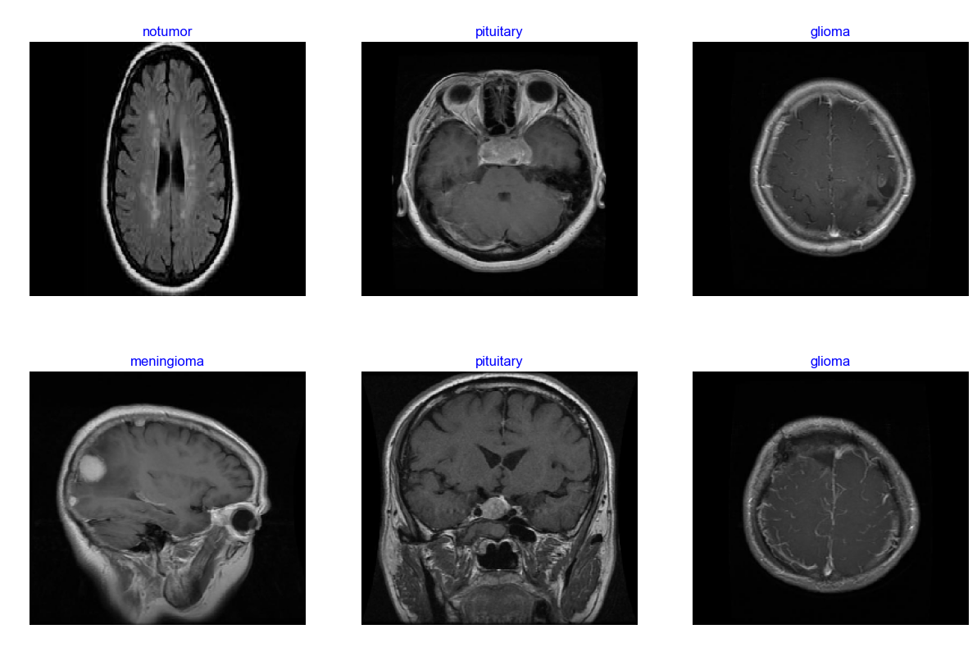
Fig. 1 Sample images

Proposed Model
The main model employed in this study, the Vision Transformer is a recently proposed transformer-based architecture for image classification tasks. The ViT model follows a similar structure to the transformer models used in natural language processing, with a few adaptations for handling image data.
The ViT architecture, displayed in Fig. 2, consists of the following components:
- Patch Embedding: The input image is split into non-overlapping patches, which are then flattened and linearly projected to form a sequence of patch embeddings. Positional embeddings are added to the patch embeddings to retain the positional information of the patches within the image.
- Transformer Encoder: The sequence of embeddings is fed into a standard transformer encoder, consisting of multiple encoder blocks. Each encoder block includes multi-head self-attention layers and feed-forward neural networks, along with layer normalization and residual connections.
- Classification Head: The output of the transformer encoder is passed through a multilayer perceptron (MLP) head to produce the final class predictions.
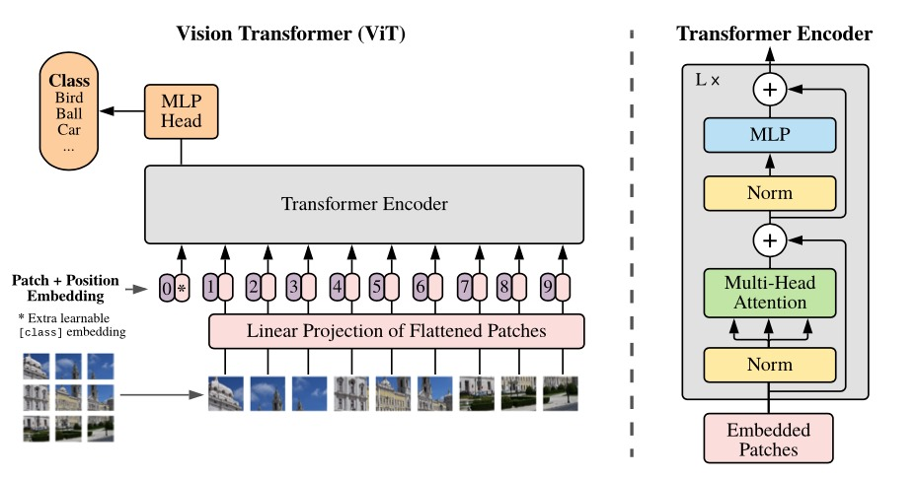
Fig. 2 ViT architecture
The input images are first divided into fixed-size, non-overlapping patches in order to function as the Vision Transformer architecture. We next perform a linear transformation on these patches to project them into a lower-dimensional embedding space. Positional encodings are added to the patch embeddings so that the patches' spatial information from the original image is preserved. The core of the ViT model consists of numerous Transformer encoder layers that use feedforward neural networks and multi-head self-attention processes. The model is able to capture feature interactions and global dependencies throughout the entire image thanks to these components.
Finally, the final class probability predictions are generated by appending a classification head, generally a multilayer perceptron, to the Transformer encoder output.
VGG16:
A popular convolutional neural network architecture that was put forward by Simonyan and Zisserman in 2014 is also used in this study as a baseline for comparison. The VGG16 model has three fully connected layers, a soft-max output layer, and 16 convolutional layers. Five blocks comprise the convolutional layers, with max-pooling layers arranged after some of the blocks to minimize the spatial dimension reduction.
ResNet50:
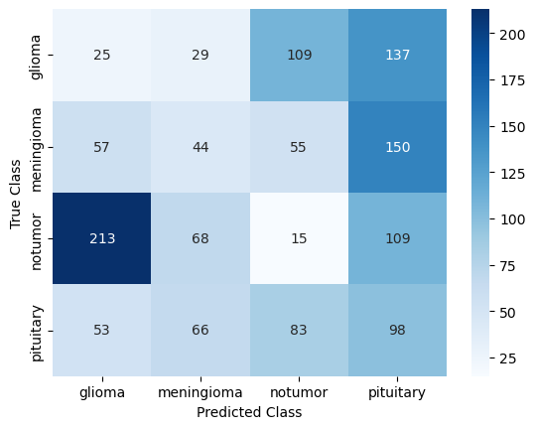
Another model used in this study is the ResNet50 model, a version of the Residual Network model, first introduced by Kaiming He et al., 2015 [21]. This model is made up of fifty convolutional layers which also include skip connections to help with training and reduce the vanishing gradient issue. By allowing more efficient gradient flow, the skip connections make it easier to train deeper neural networks.
LSTM:
Long short-term memory networks is a type of recurrent neural networks (RNN) architecture used to capture long-term dependencies in sequential data.

Performance Evaluation Metrics
To assess the performance of the classification models, several metrics such as accuracy, precision, recall, and F1 score were employed in this study.
Accuracy: This metric is the measure of the overall correctness of the proposed model’s predictions. Mathematically,
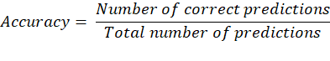
Precision: This metric is the assessment of the accuracy of the positive predictions made by the model.
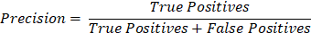

Recall: This metric is the evaluation of the model’s ability to identify all positive instances in the dataset.
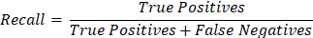

F1 score: This metric is an assessment of the model’s performance in terms of both precision and recall.
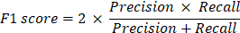

Results and Discussion
In this study, the four models mentioned earlier were implemented on the dataset, and carefully evaluated against each other. The results of the analysis are as follows:

Vision Transformer
The study presented ViT as the frontrunner, with an impressive accuracy of 95.11%. The model’s self-attention mechanism makes it remarkably efficient at image classification tasks. The confusion matrix displayed in Fig. 3 is evidence of the model’s potency in handling large and diverse image datasets.

Fig. 3 Confusion matrix: ViT

VGG16
The VGG16 model emerged as a close contender, with an accuracy of 93.92% proving its long-running reputation of being robust and reliable (see Fig. 4).
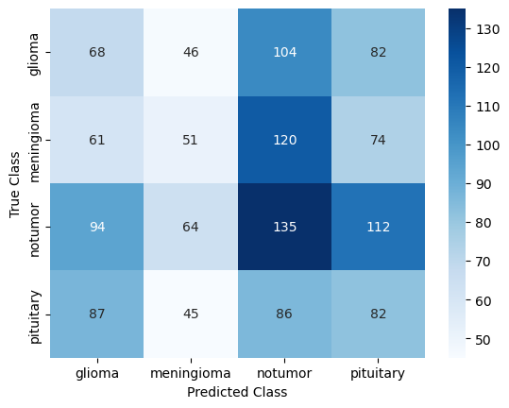
Fig. 4 Confusion matrix: VGG16

ResNet50
The next model ResNet50 showcased commendable endurance with an accuracy of 67.26%. The map in Fig. 5 is a testament to the model’s precision in image predictions.
Fig. 5 Confusion matrix: ResNet50
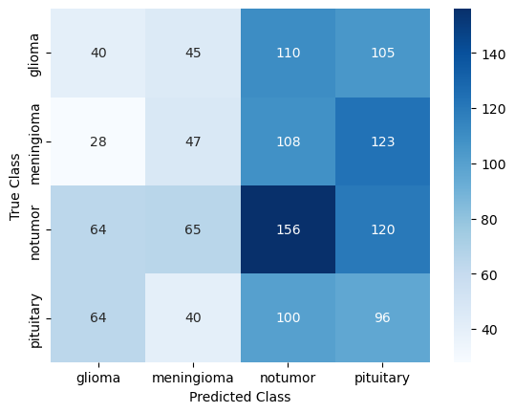

LSTM
Finally, LSTM comes at the end with an accuracy of mere 40.96%. Although it scored the least out of the four, it showed remarkable resilience amongst the contenders (see map in Fig. 6).
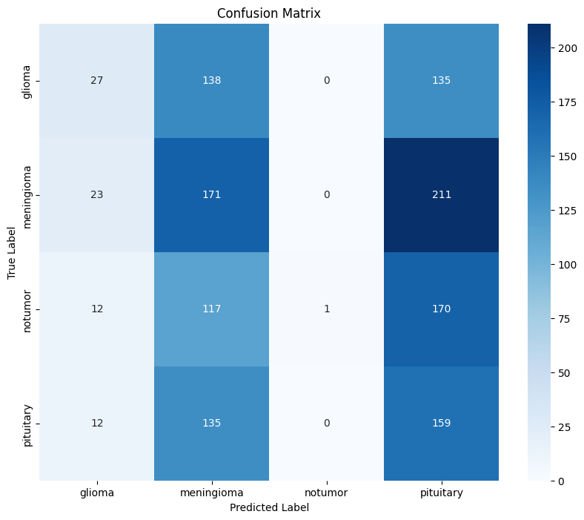
Fig. 6 Confusion matrix: LSTM
Table 2 shows the overall metric score of each model when trained and tested on brain tumor MRI image dataset through which one can clearly compare and analyse the results.
- Metric score
Model Name | Accuracy | Precision | Recall | F1 Score
ViT | 0.9511 | 0.129 | 0.138 | 0.128
VGG16 | 0.9392 | 0.255 | 0.256 | 0.253
ResNet50 | 0.6726 | 0.253 | 0.258 | 0.249
LSTM | 0.4096 | 0.476 | 0.258 | 0.207

Conclusion
Our research concludes by highlighting the important potential of the Vision Transformer (ViT) model in medical image processing, especially when it comes to the identification and categorization of brain tumors. When compared to other models, ViT's high accuracy indicates that it can be a useful tool for improving medical professionals' diagnostic skills. Moreover, our study offers significant understanding of the relative effectiveness of deep learning models in medical imaging tasks and establishes a standard for further research in this area.
In terms of future study, our findings provide a number of options. Firstly, more research may look into the viability of using ViT for tasks related to medical imaging that go beyond the identification of brain tumors, such as organ segmentation or lesion detection. Furthermore, studies could concentrate on enhancing ViT's architecture and hyperparameters to enhance its functionality in medical picture analysis. Secondly, the viability of using transformer-based models in healthcare applications is demonstrated by ViT's performance in this study. Subsequent investigations may examine the creation of customized transformer models for certain medical imaging applications, which could result in the production of more precise and effective diagnostic instruments.
This paper helps in advancing the area of medical image analysis and highlights how deep learning models, particularly, Vision Transformer, have the potential to completely transform medical diagnoses.

References

- Dandil, E. (2020), aiMRS: A feature extraction method from MRS signals based on artificial immune algorithms for classification of brain tumours. IET Signal Process., 14: 361-373. https://doi.org/10.1049/iet-spr.2019.0576
- Anil Kumar Budati, Rajesh Babu Katta for An automated brain tumor detection and classification from MRI images using machine learning techniques with IoT. Environment, Development and Sustainability (2022) 24:10570–10584 https://doi.org/10.1007/s10668-021-01861-8.
- ARI, ALİ and HANBAY, DAVUT (2018) “Deep learning-based brain tumor classification and detection system,” Turkish Journal of Electrical Engineering and Computer Sciences: Vol. 26: No. 5, Article 9. https://doi.org/10.3906/elk-1801-8 Available at: https://journals.tubitak.gov.tr/elektrik/vol26/iss5/9
- Mahmud, Md Ishtyaq, Muntasir Mamun, and Ahmed Abdelgawad. 2023. “A Deep Analysis of Brain Tumor Detection from MR Images Using Deep Learning Networks” Algorithms 16, no. 4: 176. https://doi.org/10.3390/a16040176
- Ginni Garg1, Ritu Garg (2021) for Brain Tumor Detection and Classification based on Hybrid Ensemble Classifier. arXiv:2101.00216, arXiv preprint arXiv:2101.00216, 2021 – arxiv.org
- Amin, J., Sharif, M., Haldorai, A., Yasmin, M., & Nayak, R. S. (2022). Brain tumor detection and classification using machine learning: a comprehensive survey. Complex and Intelligent Systems, 8(4), 3161–3183. https://doi.org/10.1007/s40747-021-00563-y
- Alqudah, A. M., Alquraan, H., Qasmieh, I. A., Alqudah, A., & Al-Sharu, W. (2019). Brain tumor classification using deep learning technique - A comparison between cropped, uncropped, and segmented lesion images with different sizes. International Journal of Advanced Trends in Computer Science and Engineering, 8(6), 3684–3691. https://doi.org/10.30534/ijatcse/2019/155862019
- Banerjee S, Mitra S, Masulli F, Rovetta S (2019) Deep radiomics for brain tumor detection and classification from multi-sequence MRI. arXiv:1903.09240
- Noreen, N., Palaniappan, S., Qayyum, A., Ahmad, I., Imran, M., & Shoaib, M. (2020). A Deep Learning Model Based on Concatenation Approach for the Diagnosis of Brain Tumor. IEEE Access, 8, 55135–55144. https://doi.org/10.1109/ACCESS.2020.2978629
- Dandil, E. and Biçer, A. (2020), Automatic grading of brain tumours using LSTM neural networks on magnetic resonance spectroscopy signals. IET Image Process., 14: 1967-1979. https://doi.org/10.1049/iet-ipr.2019.1416
- Musallam, A. S., Sherif, A. S., & Hussein, M. K. (2022). A New Convolutional Neural Network Architecture for Automatic Detection of Brain Tumors in Magnetic Resonance Imaging Images. IEEE Access, 10, 2775–2782. https://doi.org/10.1109/ACCESS.2022.3140289
- Khan, M. S. I., Rahman, A., Debnath, T., Karim, M. R., Nasir, M. K., Band, S. S., Mosavi, A., & Dehzangi, I. (2022). Accurate brain tumor detection using deep convolutional neural network. Computational and Structural Biotechnology Journal, 20, 4733–4745. https://doi.org/10.1016/j.csbj.2022.08.039
- Shah, H. A., Saeed, F., Yun, S., Park, J. H., Paul, A., & Kang, J. M. (2022). A Robust Approach for Brain Tumor Detection in Magnetic Resonance Images Using Finetuned EfficientNet. IEEE Access, 10, 65426–65438. https://doi.org/10.1109/ACCESS.2022.3184113
- Amin, J., Anjum, M. A., Sharif, M., Jabeen, S., Kadry, S., & Moreno Ger, P. (2022). A New Model for Brain Tumor Detection Using Ensemble Transfer Learning and Quantum Variational Classifier. Computational Intelligence and Neuroscience, 2022. https://doi.org/10.1155/2022/3236305
- Rizwan, M., Shabbir, A., Javed, A. R., Shabbir, M., Baker, T., & Al-Jumeily Obe, D. (2022). Brain Tumor and Glioma Grade Classification Using Gaussian Convolutional Neural Network. IEEE Access, 10, 29731–29740. https://doi.org/10.1109/ACCESS.2022.3153108
- Asif, S., Yi, W., Ain, Q. U., Hou, J., Yi, T., & Si, J. (2022). Improving Effectiveness of Different Deep Transfer Learning-Based Models for Detecting Brain Tumors from MR Images. IEEE Access, 10, 34716–34730. https://doi.org/10.1109/ACCESS.2022.3153306
- Nayan, A. A., Mozumder, A. N., Haque, M. R., Sifat, F. H., Mahmud, K. R., Al Azad, A. K., & Kibria, M. G. (2023). A deep learning approach for brain tumor detection using magnetic resonance imaging. International Journal of Electrical and Computer Engineering, 13(1), 1039–1047. https://doi.org/10.11591/ijece.v13i1.pp1039-1047
- Ullah N, Javed A, Alhazmi A, Hasnain SM, Tahir A, Ashraf R (2023) TumorDetNet: A unified deep learning model for brain tumor detection and classification. PLoS ONE 18(9): e0291200. https:// doi.org/10.1371/journal.pone.0291200
- Saeedi, S., Rezayi, S., Keshavarz, H. et al. MRI-based brain tumor detection using convolutional deep learning methods and chosen machine learning techniques. BMC Med Inform Decis Mak 23, 16 (2023). https://doi.org/10.1186/s12911-023-02114-6
- Woźniak, M., Siłka, J. & Wieczorek, M. Deep neural network correlation learning mechanism for CT brain tumor detection. Neural Comput & Applic 35, 14611–14626 (2023). https://doi.org/10.1007/s00521-021-05841-x
- K. He, X. Zhang, S. Ren and J. Sun, "Deep Residual Learning for Image Recognition," 2016 IEEE Conference on Computer Vision and Pattern Recognition (CVPR), Las Vegas, NV, USA, 2016, pp. 770-778, doi: 10.1109/CVPR.2016.90.

